Images of our 2021 Christmas Activities

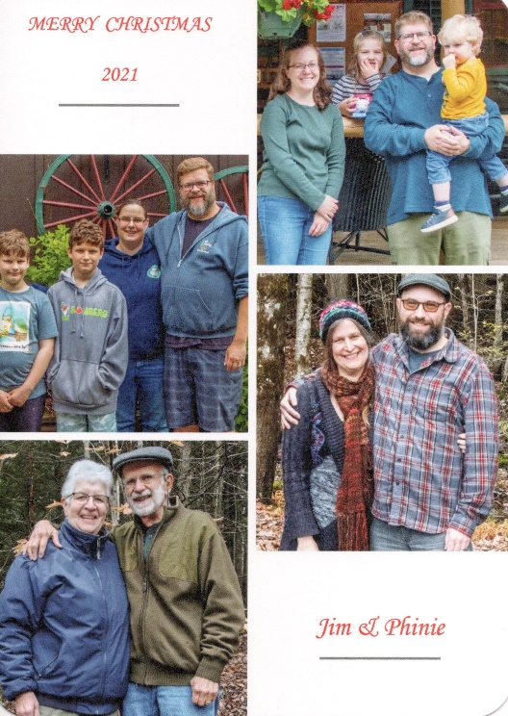

Christmas is the world-wide celebration of the birth of Jesus Christ. This is the third year of the continuing infestation of COVID-19 and we are fortunate that our four families have been un-affected but challenged in physically communicating.

This album contains scenes of Christmastime activities focusing on the families gathering at Jim & Phinie’s in Keene celebrating Christmas the weekend before his birthday.

And for the photos, click on [2021 Christmas](https://photos.app.goo.gl/t3X35LYXmUkWzCAF9). And feel free to “zoom”.